Team Member(s): William Banks

Supervisor: Dr. Franz Baudenbacher

Title: Model-Integrated Computing Design Principles for Biomedical Engineering Applications

Description:

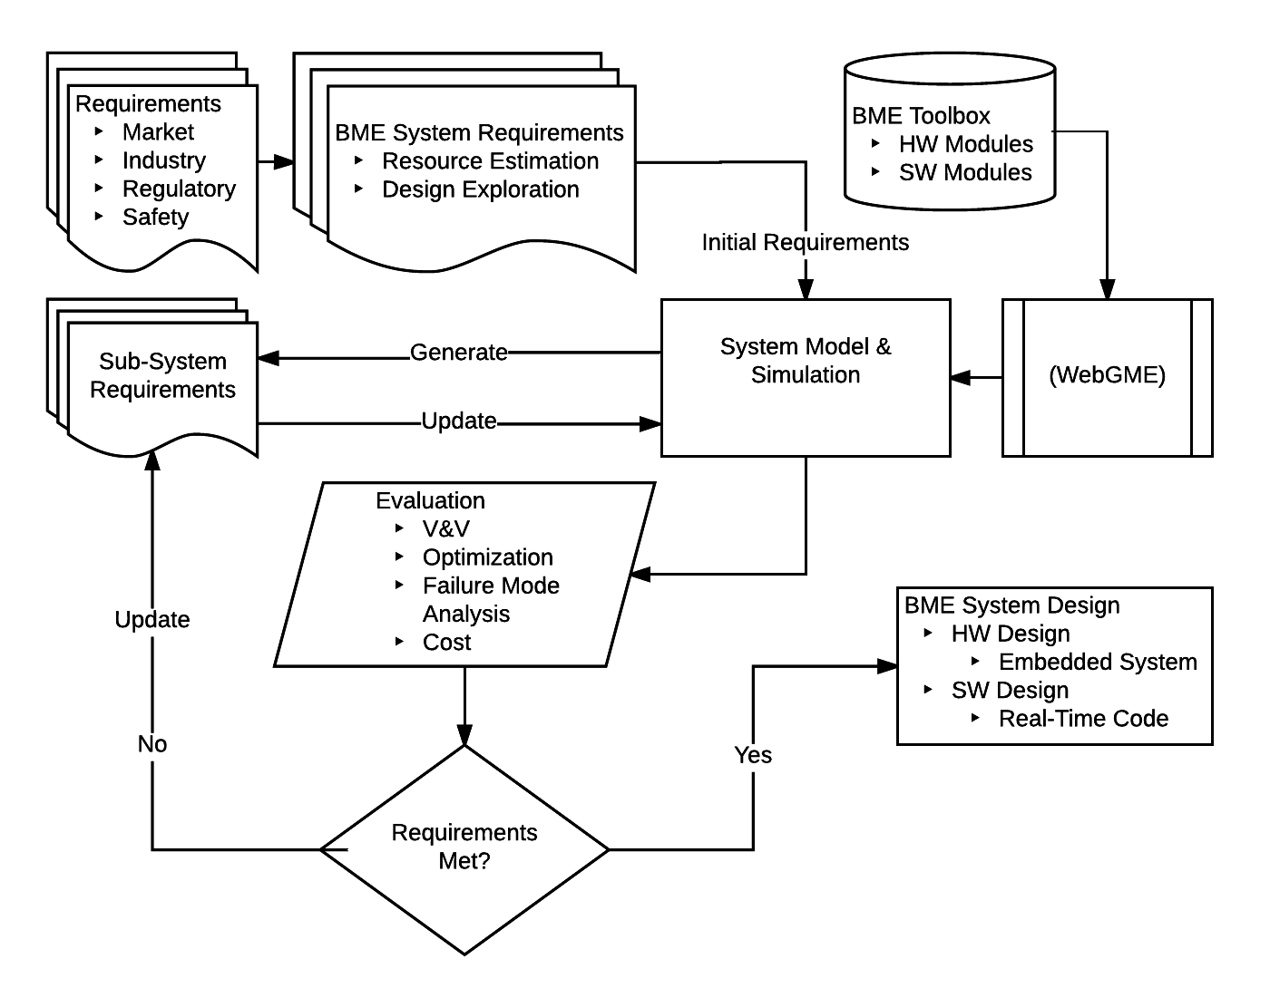

Figure 1 BME MIC design flow

The purpose of this project is to incorporate model-integrated computing (MIC) principles into the design process of biomedical engineering (BME) systems.

Currently, the development cycle for BME systems is costly and time consuming. The FDA regulation pathway alone can take up to 75% of the effort. Reducing the time to develop BME systems and streamline the regulation pathway is of great value and a MIC approach can achieve this goal.

In typical design paradigms, system changes are evaluated piecemeal. By leveraging the advantages of MIC, continuous test and update cycles can be incorporated into a system model. For example, in a traditional design scheme, a system is designed with a 16bit ADC. Due to circumstances, the 16bit converter is replaced with a 24bit variant. This results in a change in data format and requires an algorithm rewrite and additional impact analysis. With MIC principles, instead of lengthy testing of individual changes, component attributes can be updated dynamically within a well-defined DSML and V&V can be done automatically and are self-documenting

Another important area is risk analysis which can be executed with greater efficiency within a DSML framework. For instance, a pressure transducer has a Δm = 1% at a cost of $5.00. A cheaper transducer with a cost of $1.50 and a Δm = 1.5% is being considered to cut production costs but requires FDA approval. Component modeling allows quick parameter changes and automated V&V of the alternate part. This can then be submitted as a white paper and additional costs are reduced.

Goals/Milestones:

1. Assess current DSMLs for BME applications
2. Develop DSML for BME applications that incorporates regulatory and industry requirements as attributes of components.
   1. Focus on design space and constraint modeling, safety, risk analysis
   2. Identify attributes and attribute values unique to BME
3. Develop a library of components
4. Use components to design application (closed feedback system: insulin pump, data recorder-to--MD, venous pressure monitor, etc.)
   1. Show that modeling can be used to refine the design through recursive requirement updates: Sys. Reqs🡪Model🡪V&V🡪 Sub-Sys. Reqs.🡪 Model🡪 V&V🡪. . . . 🡪Design
   2. Self-documentation of performance progression, safety and regulatory pathway
5. Establish method to expand component library